Money

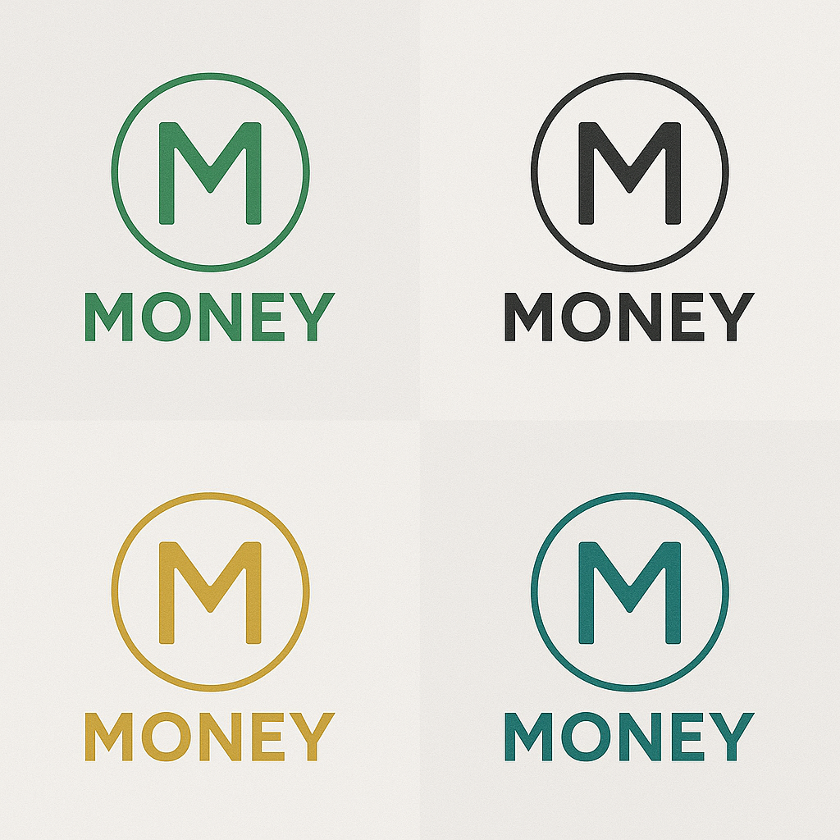
Money: A Simple Guide to the People's Ledger

What is Money?

Money is a decentralized, eco-friendly money that doesn't require mining, blockchain, or energy-intensive systems. It runs on smartphones. It is validated by people. It belongs to everyone.

The Philosophy
- No pre-mine
- No CEO
- No hidden rules
- No elite validators
- No coins given to insiders

Just people. Just phones. Just Money.

How It Works
1. Send a Transaction
- You open the Money app
- You send MONEY to someone

2. Swarm Validation Begins
- The transaction is broadcast to a group of randomly selected smartphones
- Each phone verifies:
- The signature is valid
- The sender has enough balance
- The transaction has not been seen before

3. Consensus via Signatures
- Once a threshold number of phones validate it (e.g. 500+), the transaction is considered confirmed
- The state of the ledger updates for all

4. Ledger Sync
- Every phone holds a copy of the current state
- Syncs happen via a lightweight gossip protocol with Merkle proof integrity

Privacy
Money uses full privacy by default. No one can see who sent what to whom. Even validators can’t see the real amounts.
Supply
- Starts at 1,000,000 MONEY
- For every 1,000,000 new verified users, 1,000,000 new MONEY are created and distributed amongst every user that has an account equally
- No central issuance. No inflation unless the people grow.
What Counts as a Verified User?
A smartphone that:

- Has the Money app installed
- Is helping validate transactions
- Uses a unique IP address

Only one active device per IP is counted toward user growth. The goal is to remove greed from the equation. Just the payment is the goal. Transaction finality is the only goal. Nothing more. The reward is that you can use it. No incentive, no greed, no trading. This technology is simple, it belongs to the people. Greedy corporations will not be able to corrupt this tech.

No Rewards?
Correct. Validators do not earn MONEY. This keeps the system honest, free from greed, and resistant to centralized exploitation.

Why Use Money?
- Instant transactions.
- Near-zero fees.
- No third parties.
- Works anywhere with a smartphone and internet.
- Can’t be censored, paused, or defunded.

Who Built Money?
No one knows. And it doesn’t matter. The rules are open. The code is public. The ledger is yours.
Tagline
Money. For Everyone. Forever.

